**DAILY ONLINE ACTIVITIES SUMMARY**

|  |  |  |  |  |  |  |  |
| --- | --- | --- | --- | --- | --- | --- | --- |
| **Date:** | **20-05-2020** | | | | **Name:** | **Gudugunti Anirudh** | |
| **Sem & Sec** | **IV - A** | | | | **USN:** | **4al18cs023** | |
| **Online Test Summary** | | | | | | | |
| **Subject** | | **OOC** | | | | | |
| **Max. Marks** | | **30** | | **Score** | | **16** | |
| **Certification Course Summary** | | | | | | | |
| **Course** | **Python in ML** | | | | | | |
| **Certificate Provider** | | | **Great learning academy** | **Duration** | | | **2hrs** |
| **Coding Challenges** | | | | | | | |
| **Problem Statement:** 1. reversing a number in python  2. Given an array a[] of size n which contains elements from 0 to n-1, write a program printduplicate elements of the given array. If no duplicate element is found print -1.  3. Write a C Program to Reverse a Linked List (SLL) in groups of given size. | | | | | | | |
| **Status: Uploaded** | | | | | | | |
| **Uploaded the report in Github** | | | | **Yes** | | | |
| **If yes Repository name** | | | | **https://github.com/Anirudh23-23/Daily-progress** | | | |
| **Uploaded the report in slack** | | | | **Yes** | | | |

Online Test Details: The online test was from module 1 which was about C++ PROGRAMMING. There were 20 MCQ and 10 program questions and the duration were 30 minutes. The questions were optimal. The score that I received was 16/30.

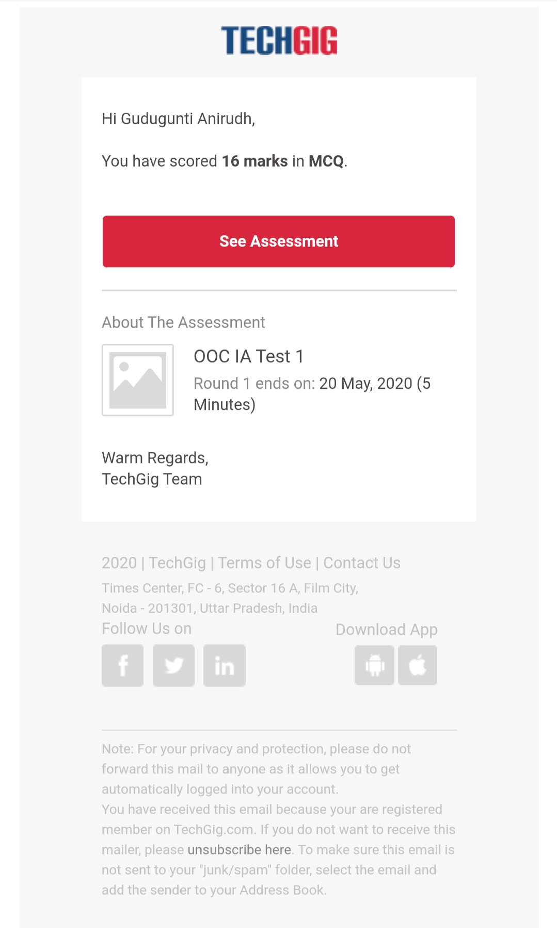

Snap shot:

Certification Course Details:

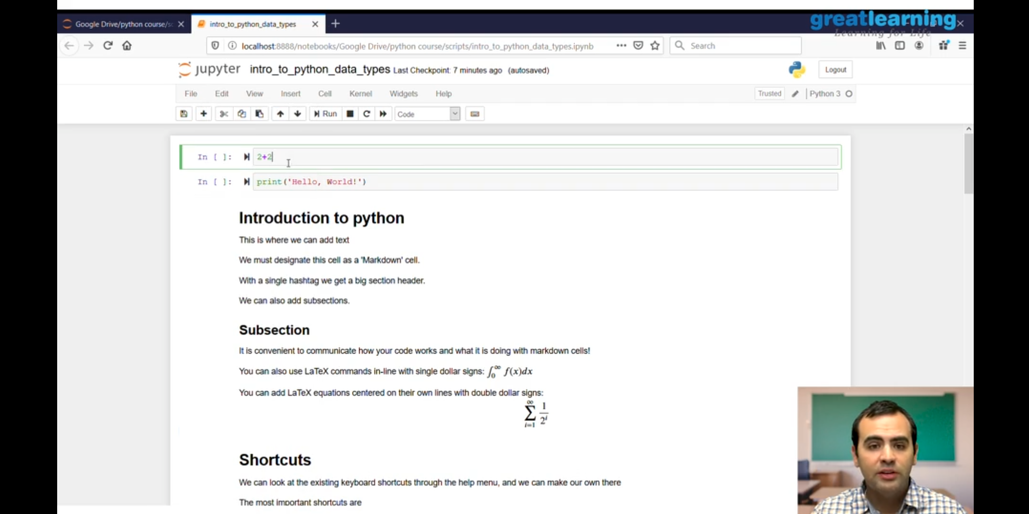

1.Introduction to python.

2.Short cuts to python.

3.Sub sections in python.

Coding Challenges Details:

Problem 1: Write Python Program to Reverse a Given Number.This is a Python Program reverse a given number.

Problem Description:The program takes a number and reverses it and store it in another variable and show it.

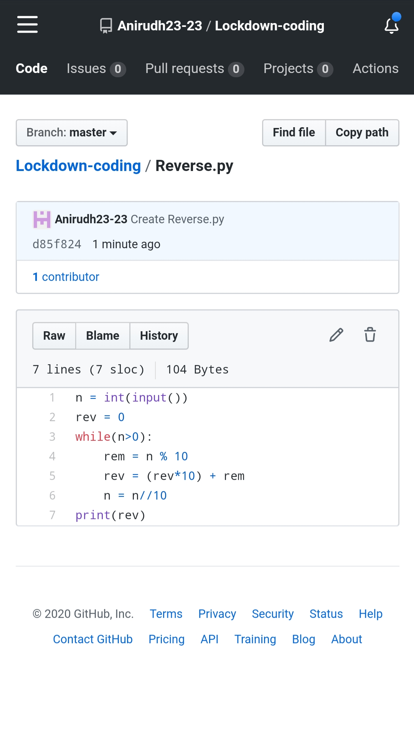

Problem 2: (Using JAVA) Given an array a[] of size n which contains elements from 0 to n-1, write a program printDuplicates which prints the duplicate elements of the given array. If no duplicate element is found print -1.

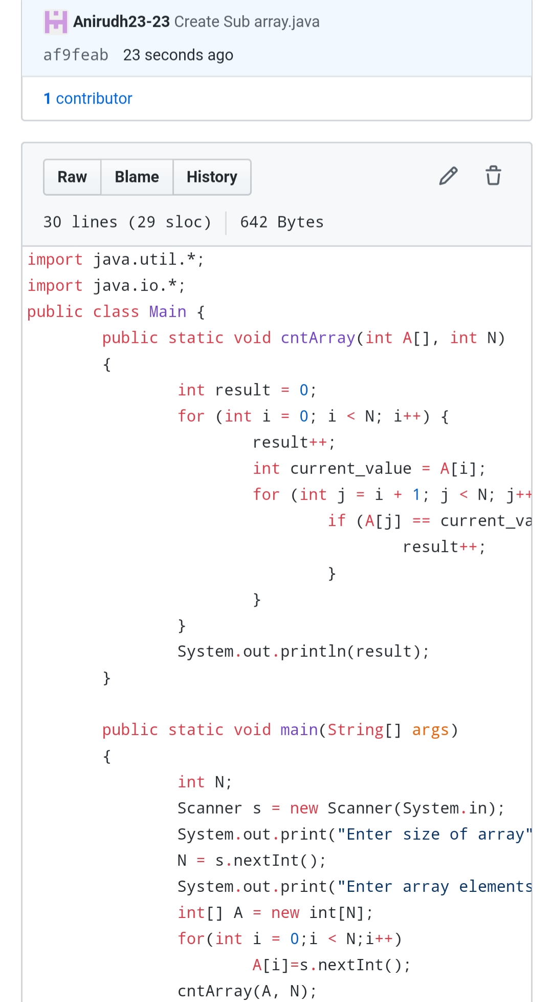

Problem 3: (using C language) Write a C Program to Reverse a Linked List (SLL) in groups of given size.

